pplogobw

**Hartwell Pocket Park**

**Ashwood Acre**

**Management Plan 2008 – 2017**

**Minor updates and revisions January 2017**

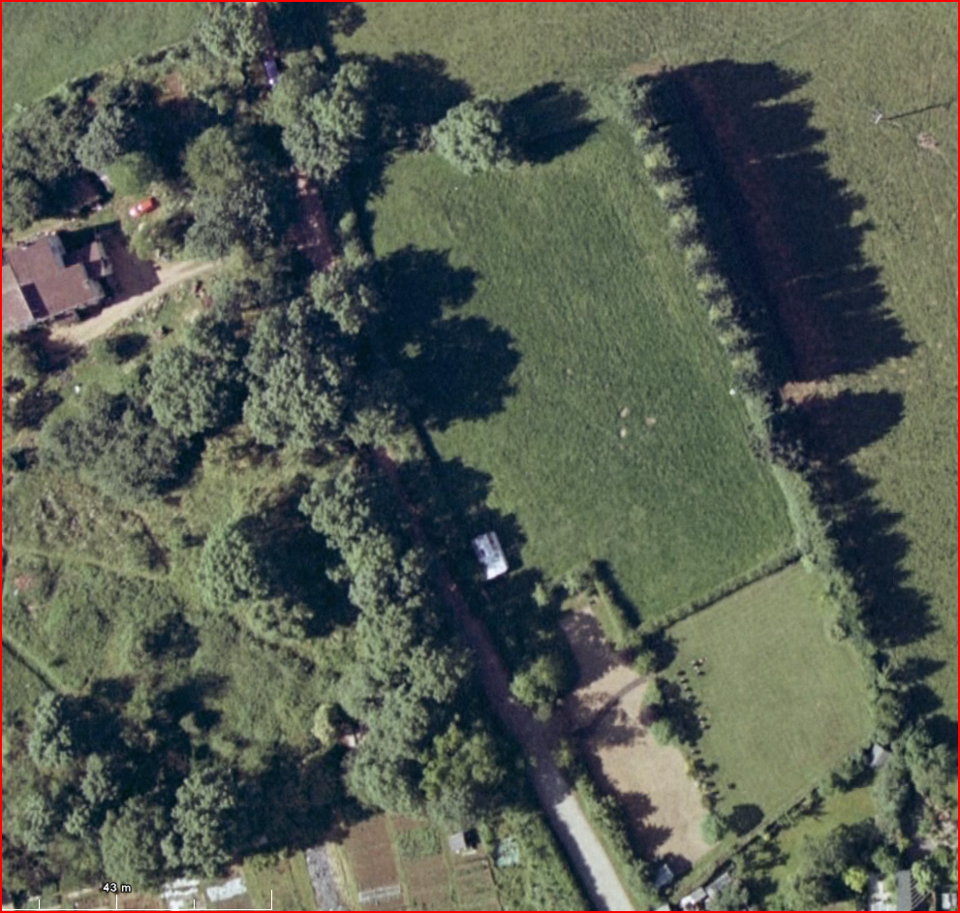

**Proposed site**

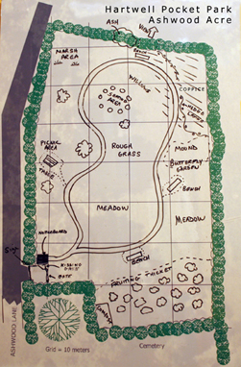

**Cemetery**

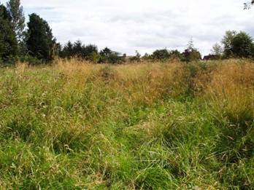

|  |  |
| --- | --- |
| **Contents** | *Page* |
| Aims and objectives | 4 |
| Description and location of the site | 5 |
| Maps & level survey of the site | 5 |
| History and ownership of the site | 8 |
| An evaluation of the site   * Conservation and wildlife potential * Recreational * Educational | 8 |
| Management of the site | 10 |
| Community and volunteer involvement | 10 |
| Initial Aerial photo and proposed plan for park | 11 |
| Features of plan | 12 |
| Creating formal access | 14 |
| Movement around the site – paths | 14 |
| Signs, notice boards and interpretation | 14 |
| Community use of the park | 14 |
| Countryside crafts and skills | 14 |
| Health and safety | 15 |
| Funding | 15 |
| Initial five year work plan 2008 – 2012 | 16 |
| Local contacts and sources of information | 18 |

|  |  |
| --- | --- |
| **Appendices** |  |
| Appendix 1 Wildlife Trust Survey including species lists | 20 |
| Appendix 2 Constitution | 28 |
| Appendix 3 Advice from Northants Police | 33 |
| Appendix 4 Health and Safety Risk Assessments | 34 |
| Appendix 5 Five Year Plan 2013 - 2017 | 42 |
| Appendix 6 Evaluation of progress January 2015 | 48 |

**Aims and objectives**

**AIMS**

* To create the park as an area for quiet enjoyment, recreation and education for the benefit of members of the community of all ages.
* To maintain and further develop the current ecological diversity of the site to encourage plant and animal life.
* To encourage local residents in working together to support, care for and enjoy the area.

**OBJECTIVES**

1a. The park should be capable of a variety of quiet uses by individuals, small groups, village groups and include a small space where people could gather for quiet events.

1b. The park will be attractive to young children with paths, places to explore and things to observe enabling them to enjoy and respect the countryside.

1c. The park will enable demonstrations of country crafts and skills such as hedge laying and species identification.

1d. The park will feature interesting artefacts e.g. sculptures, willow structures, log seating in keeping with its natural surroundings.

1e. The park will have seating to allow people to relax and enjoy the park.

1f. Interpretation and notice boards will inform visitors about interesting features, wildlife news and group activities and events.

1g. The group will monitor park features such as seating, information boards and maintain when necessary

1h. The management group will organise an annual community fundraising/social event.

1i. A short section of the northern hedge will be cut to create a view across to Rowley Wood from Pocket Park.

1j. The management group will liaise with and encourage Hartwell village school to visit pocket park.

2a. The park design will include a variety of areas of interest such as woodland, wild

flower meadow, an edible thicket, a marshy area and a butterfly garden while maintaining the current diversity of the hedgerows and grassland.

2b. The three grassland areas - wildflower meadow, long grass, & marshy patch will be maintained and improved through appropriate cutting, raking & removing of arisings regimes.

2c. A compost area for arisings will be created and in turn a grass snake habitat.

2d. Hedges will be maintained through trimming or laying following advice from Wildlife Trust or other expert.

2e. A coppice area will be planted and maintained through rotational cutting. During planting consideration will be given to the opportunity of introducing wildflowers.

2f. The butterfly area will be regularly weeded, pruned and maintained.

2g. A fruiting thicket will be planted and maintained through mulching, pruning, weeding etc.

2h. A mound will be created which can be maintained through cutting, raking and removing arisings.

3a. Through strong initial design, the space will be inviting and accessible to all with

pathways that draw visitors to key features.

3b. The site will be capable of maintenance by volunteer working groups with some locally funded professional support.

3c. Moral, practical and financial support will be encouraged from individuals and community groups through regular publicity, working groups and activities at the park.

3d. There will be good and regular communication with the church, parish council, Pocket Parks Officer etc.

3e. The Pocket Park Management Group will meet regularly to monitor and plan actions required to complete the works as described in the Management Plan.

3f. Write & review when necessary risk assessments.

**Description and location of the site**

The site which measures just under an acre (0.3 hectares) is to the west of Hartwell village (OS Grid Reference SP783505). It is approached along Rowley Wood Lane (sometimes known as Ashwood Lane) from Ashton Road. This lane is also a bridleway No. KR32 which links to Quinton and Courteenhall and a network of local paths. Rowley Wood Lane is a made road as far as the site entrance after which it becomes a farm track. This means that public access to the site is easy and level though the road has no pavements. Traffic volumes on the approach road are fairly low as there are only three properties further along the lane. Rowley Wood Lane is a popular approach to local footpaths and well used by residents walking dogs. The site is to the north of the new Hartwell cemetery and forms part of the land designated for cemetery use by the Parish Council in 1989.

Until about 2005 the site was a pasture field used for sheep grazing. A small barn building near the entrance to the site was demolished in 2006 for safety reasons. The concrete base remains.

The southern boundary of the site is a dense thorn hedge maintained at about 120 cm high as part of the cemetery maintenance contract. Other boundaries are wild, mixed hedgerows, species rich to the west and north. The western boundary is flail cut on the bridleway side each autumn. No maintenance work is done on the other hedgerows which are punctuated by mature trees. Outside the eastern boundary hedgerow is a row of mature poplar and conifer trees. The site is rough grassland, level at the southern end but sloping gently towards the northern boundary.

The site is surrounded on the east and north by pastureland. A few hundred metres to the south is Rowley Wood, a privately managed bird sanctuary to which there is no public access.

The Pocket Park site outlined in red.

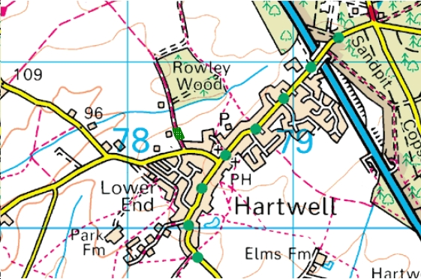

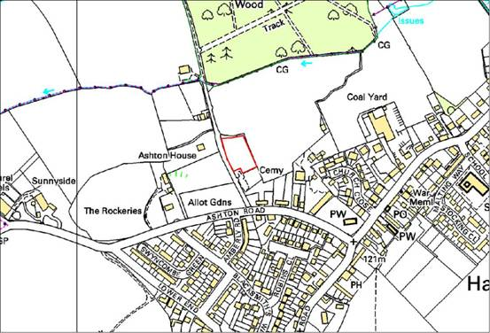**Site level survey**

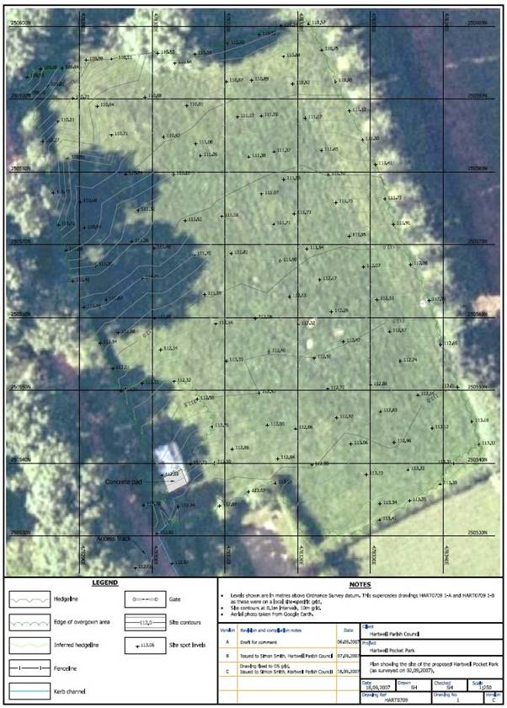**History and ownership of the site**

The site of the park together with the neighbouring land, now the new cemetery, was acquired by the Parish Council in 1989. Prior to this it was owned by Hartwell Parish Church. The land, as far as can be ascertained from searches in Peterborough Diocesan Records, national Church of England records and the Land Registry, is not subject to any covenants or restrictions as to its use but the primary purpose of the whole area (cemetery and pocket park site) is to provide adequate land for burials. The existing cemetery site is not likely to run short of space for many decades thus fulfilling the requirement that a pocket park site should have a life of at least 25 years. it is assumed that should further land be needed for burials the cemetery would be extended into the southern end of the park site.

**An evaluation of the site**

**Conservation and wildlife potential**

An ecological survey of Hartwell Pocket Park was carried out by the Northamptonshire Wildlife Trust (2007) to assess the habitats and species of interest present. In summary the survey concluded:

* the site is mostly comprised of grassland, bordered by hedgerows of varying ecological quality.
* the biodiversity value of the grassland is mixed. Some patches comprise rank, species-poor sward whilst other patches are slightly more species-rich, containing some interesting wildflowers.
* at the time of the survey (July 2007) the sward height over much of the field was described as too tall, about 50 cm.
* the hedgerows to the west and north are relatively species-rich and are good wildlife refuges and corridors. Trimming of the hedges is not recommended and should be minimised, particularly during the summer whilst birds are nesting.
* it is recommended that one or two cuts are taken of the grassland per year, one in spring and one in late summer. *All cuttings should be removed so as to prevent build-up of nutrients*. This process should reduce the sward height and increase the diversity of both botanical and invertebrate species. It would also result in a more accessible and pleasant site for the local community to enjoy.

The guidance from the Wildlife Trust was seen as a good basis for the development and management of the park. It is a key objective of the park that the site becomes a more diverse habitat. Planting and maintenance will encourage wildlife and be designed to build the diversity of flora through good management of the grassland and of newly planted areas. Paths will be designed to minimise disturbance to wild life and existing plants but provide access for observation and exploration. There will be a variety of areas of interest e.g. open areas, woodland, wild flower meadow, marsh area. Notice boards will encourage public interest in plant and animal life and encourage visitors to use the park in a manner consistent with maintaining and enhancing diversity.

(Objectives 2a, 2c)

**Recreational**

The park is intended to be an area for quiet recreation. Layout and planting will encourage exploration and observation. Well placed seating, sculptures and woven willow structures would encourage this. It is not intended that this relatively small space will become an area where boisterous games are played or large events are held. This reflects the intention of the group to organise a space which is consistent with the needs of visitors to the adjacent cemetery. It is intended that the park would be a place for quiet contemplation which would be welcomed and used by visitors to the cemetery.

Examples of quiet recreation would include nature observation, bird watching, plant identification and enjoyment of the quiet atmosphere and changing seasons. Small meetings of groups might take place in the circular log seating area. It is intended that the small groups of children from the school and local organisations (e.g. pre-school, beavers, brownies, guides) would use the park under supervision and for activities consistent with its conservation purpose. Similarly the Women’s Institute, Church groups or the Tuesday Circle might on occasions use the park.

The process of bringing groups of volunteers together to plant and maintain the park will also contribute for those involved to the recreational activity purpose of the park.

(Objectives 1a, 1b, 1c, 1d, 3b, 3c)

**Educational**

The location of the park on the edge of the countryside and close to a bird sanctuary means that it will become a good educational resource. Current diversity (e.g. the hedgerows) will be maintained and other aspects (e.g. rough grassland) will be enhanced by new planting and good management. The park will be a particularly good resource for education in nature conservation and appreciation of the diversity of the countryside. The commitment of local groups to the project is an indicator that, as it develops, the park in itself will be an educational resource. The planting of the ‘fruiting thicket’ will encourage wildlife. Different parts of the site are already home to a variety of insect species and this will be further developed though management and planting e.g. bee and butterfly garden and the possible addition at a later date of a pond within the site. (There are two natural ponds close to the site).

In addition the park will be used for demonstrations of skills and crafts connected with the countryside e.g. hedge laying, species identification. A small woodland area will be bordered with a newly planted mixed hedge which can be properly laid and managed to provide an attractive feature highly supportive of wildlife.

(Objectives 1c, 1d, 2b, 2c)

**Management of the site – management group and relationship with Parish Council**

The park will be managed by a group which is a working group associated with the Parish Council. The membership and working of the management group, financial arrangements, appointment and voting procedures and voting rights at annual meetings are set out in a written constitution (Appendix 2).

The management group currently has ten members including a Chair who is also a parish councillor, a secretary and a treasurer who is the Parish Clerk. This enables the group to act autonomously in planning the development of the park while being closely associated with the formal activity of the Parish Council which owns and takes responsibility for the site. The insurance for the site is provided through the Parish Council. (Current management group membership – see appendix 3)

The pocket park management group manages the site as detailed in the Management Plan. This is the shared vision and is approved by Northamptonshire County Council, South Northamptonshire Council and Hartwell Parish Council. During its development there has been consultation with the residents of Hartwell as described below.

Local organisations and residents in sympathy with the aims and objectives of the park are invited to become *Friends of Hartwell Pocket Park.* This entitles all Friends to regular updates on progress in developing the park and confers voting rights at annual and extraordinary general meetings.

(Objectives 3c, 3d, 3e)

**Community and volunteer involvement**

After local consultation the parish council approached the Northants Pocket Parks Officer. The pocket park project began to take shape after the well-attended annual parish meeting in June 2007 at which the idea of a pocket park was promoted by an exhibition stand. The Parish Council had already agreed the principle to the idea of establishing the park. People who had expressed an interest at the meeting were subsequently invited to an inaugural meeting out of which an interim management group was formed. The group and other volunteers are diverse in age, interests and membership of community groups.

From the start the management group has endeavoured to enlist local interest and support through open group meetings, press releases, contacting village groups to enlist their support, features in the Parish Council magazine *Hartbeat* and most particularly by a whole village event at the park site in October 2007 which attracted over 60 people. This event demonstrated a groundswell of support from people of all ages and enabled residents to have a say in the park use and design and in suggesting a name for the park. The event also swelled the list of individuals who are willing to give practical support as volunteers.

The park project thus has good community support with local groups which want to be involved, strong and practical support from the Parish Council and an active group. The group has benefited throughout from support, advice and practical help from the Northants County Council Pocket Parks Officer.

There are currently about 50 local residents who have volunteered to join working parties to take the park forward.

(Objectives 1a, 3b, 3c)

**Initial Aerial photo of site**

**Proposed site**

**Cemetery**



**Plan of the proposed park (2008)**

The plan for the park is designed to fulfil the objectives for the park. See below.

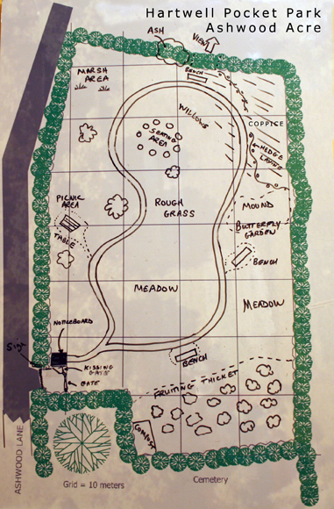

***Features of the plan:***

* A wheelchair accessible entrance (kissing gate) leading to the permanent hard footpath designed to draw visitors into and round the park so that its different features are visited. There will be open sight lines across the park from the entrance at the south west towards the north east corner to aid security. (Objectives 1a, 1b, 3a)
* An information board adjacent to the kissing gate drawing attention to the plant and wild life to be found in the park. (Objective 2a)
* A wider wooden gate which will allow occasional access for contractors’ vehicles when necessary.
* Rough grass areas with varying characters along the hedgerows with some maintained grass paths to encourage further exploration. (Objectives 1b, 2a, 2c, 3a)
* A marshy area at the north-west corner will be maintained to improve the characteristics of this damp area marked by sedge grasses. (Objective 2a, 2c)
* A circular log seating area at the northern end and near this and to the north of the path willow structures and sculptures. (Objectives 1a, 1b, 1d)
* A small area of newly planted mixed woodland to the north-east corner including trees suitable for coppicing. This area will be enclosed by a newly planted mixed hedge which will further develop the habitat and enable volunteers to learn and use hedge laying skills. (Objectives 1c, 2a, 2c)
* The arisings from the excavation for the foundation of the permanent footpath will be deposited on the eastern side creating a mound which will form part of the butterfly area. (Objectives 1b, 2a)
* An area featuring plants attractive to butterflies and other nectar loving insects will be developed on the east side. (Objectives 1b, 1c, 2a, 2b, 2c)
* Apart from a small ‘picnic area’ on the western side most of the grass will be allowed to grow between spring and late summer with occasional mows to allow access to parts of the boundary hedgerows. (Objectives 1a, 1b, 2c, 3a)
* In the south-eastern quarter of the site the permanent path will traverse a meadow area. This will be mown at appropriate times to encourage growing diversity of flora. (Objective 2a, 2c)
* At the southern end will be a ‘fruiting thicket’. The edible theme of this area is designed to benefit wildlife but also to be of human interest. This will feature native fruiting trees and shrubs but may also include any local cultivated varieties that can be identified and sourced. Some of the planting here will be of semi-mature specimens to speed the screening of the cemetery from the rest of the park. (Objectives 1a, 1b, 1c, 2a, 2c)
* At various points around the park there will be simple benches to encourage visitors to rest and observe what is growing and living in the park. (Objectives 1a, 3a)
* The mature trees growing through the boundary hedges will be a ‘borrowed’ feature of the park. It may also be possible by careful reduction of the hedgerow height for a small section of the northern boundary to borrow a view towards the Rowley Wood bird sanctuary. (Objective 1a. 2a, 2c)
* A small number of larger specimen trees will be located along the permanent path. (Objective 2c)

**Access and pathways**

The site was originally rough pasture land gently sloping towards the north. It is readily accessible from Ashton Road via Rowley Wood Lane along a made road which ends very close to the entrance. The entrance area and the permanent gravelled paths have been installed to allow easy access to wheelchair users and people with pushchairs. The sward areas away from the proposed route of the main path are uneven in places. As the park has developed and it has become clearer how it is used it would be possible to make some grass paths worn by animals and people more even. (Objective 1a)

**Signs, notice boards and interpretation**

The park will be signed from the main road and clearly marked at the entrance. A notice board near the entrance will feature a plan of the park and information about how it is managed. A key purpose of the notice boards will be interpretation of the site – its history, ecology and what to look for at different seasons. As the park develops, key features will be highlighted and identified by small notices around the park. The interpretation boards will also draw attention to features of the park which seek to increase its diversity. (Objectives 1b, 2b)

**Community Use**

From its inception the park has been seen as a community facility. There had been no public access to the site in the past and the creation of the park has brought a new feature to the village unlike anything that currently exists. The park is intended to be of interest to people of all ages. It is intended that it will be a springboard for those residents who rarely venture into the countryside and a quiet place to visit and sit for those who do not have the capacity to venture far. Interpretation boards are intended to develop appreciation of the richness and diversity of the area. It will, through the involvement of the school and other groups for children, introduce young people to sights and activities they might otherwise miss. Adult community groups such as the Women’s institute and the Tuesday Circle will also be drawn in. A growing band of Friends and volunteers will benefit from involvement in developing and maintaining the park and meeting residents they might not encounter in any other way. (Objectives 1a, 1b, 2b, 3a, 3b, 3c)

**Countryside crafts and skills**

The park will be an educational resource for the village of interest to people of all ages. The accessibility of a variety of habitats will encourage visitors to develop their skills in identifying animals, birds, insects, plants and trees. The process of managing and maintaining the park will develop these skills among those who volunteer to help. In addition there will be more formal opportunities for visitors to learn and practice new skills and crafts with the guidance of experts and enthusiasts. (Objective 1c)

**Health and safety**

**Risk assessments have been carried out / reviewed for the whole site as well as task specific activities. See appendix 4.**

**Original Funding estimates 2008**

Progress on the implementation of the management plan depends on Northants County Council pocket park grant funding. The match funding required to release this grant is available through the Parish Council.

**The pocket park grant and match funding will fund:**

The construction of the main pathway around the site approx £2,150

Erection of notice/interpretation boards + direction sign approx £ 750

Tree and hedge planting approx £1,000

Access gates and fences approx £ 700

Tools approx £ 600

Contingency approx £ 370

**Local funding (Parish Council grant and fund raising) will cover:**

Purchase of benches, picnic bench and installation of seating area approx £1,500

Initial mowing approx £ 200

Estimated annual maintenance costs £ 300

**Hartwell Pocket Park ­Initial five year work plan 2008 - 2012**

|  |  |  |  |  |  |  |
| --- | --- | --- | --- | --- | --- | --- |
|  | **MANAGEMENT OPERATIONS** | **2008** | **2009** | **2010** | **2011** | **2012** |
| **Access and security** | Install wheelchair accessible kissing gate | Spring |  |  |  |  |
|  | Install wide access gate | Spring |  |  |  |  |
|  | Install hard surface path and entrance way | Early summer |  |  |  |  |
|  | First mow of whole site | Spring |  |  |  |  |
|  | Maintain/weed main path | Spring/ summer | Spring/ summer | Spring/ summer | Spring/ summer | Spring/ summer |
|  | Regular checks of site | Ongoing | Ongoing | Ongoing | Ongoing | Ongoing |
|  |  |  |  |  |  |  |
| **Habitat creation** | Initial planting of trees and shrubs (fruiting thicket) | Spring |  |  |  |  |
|  | Make and install bird and bat boxes |  |  |  | Spring | Spring |
|  | Hedge planting and laying | Autumn | Winter |  |  | [Layer  demonstration  hedge in 2014] |
|  | Plant coppice |  | Winter |  |  | [Consider first cut  of coppice 2014] |
|  | Plant specimen trees |  | Winter |  |  |  |
|  | Plant heritage fruit trees (official opening) |  | Summer |  |  |  |
|  | Arrange dead wood piles |  | Winter/spring | Winter/spring | Winter/spring | Winter/spring |
|  | Plant butterfly bank |  | Spring/ summer |  |  |  |
|  | Extend and plant butterfly bank by stages |  |  | Ongoing | Ongoing | Ongoing |
|  | Bulb planting |  |  | Autumn | Autumn |  |
|  |  |  |  |  |  |  |
| **Habitat manage-ment** | Mow managed grass areas – remove arisings – composting | Spring and late summer | Late summer | Late summer | Late summer | Late summer |
|  | Mow meadow area | Late summer | Late summer | Late summer | Late summer | Late summer |
|  | Mow grass paths |  | Throughout growing season | Throughout growing season | Throughout growing season | Throughout growing  season |
|  | Clear around newly planted trees | Spring/  Summer | Spring/  Summer | Throughout year as necessary | Throughout year as necessary | Throughout year as necessary |
|  | Cut back perimeter hedge |  | Autumn/ winter | Autumn/winter | Autumn/winter | Autumn/winter |
|  | Maintain butterfly bank | Spring/  summer/  autumn | Spring/  summer/  autumn | Spring/summer/autumn | Spring/summer/autumn | Spring/summer  /autumn |
| **Facility install-**  **ation and manage-ment** | Install benches | Summer | Summer |  |  |  |
|  | Annual inspection of equipment and remedial action |  | Summer | Summer | Summer | Summer |
|  | Health and safety audit and follow up | Spring | Spring | Spring | Spring | Spring |
|  | Mow grass paths | Summer | Summer | Summer | Summer | Summer |
| **Commun-ication** | Erect signs to park and interpretative notice boards |  | Spring/  Summer |  |  |  |
|  | Updates on events and activities in *Hartbeat* | Spring/  Autumn | Spring/  Autumn | Spring/  Autumn | Spring/  autumn | Spring/  autumn |
|  | Annual report and AGM | Summer | Summer | Summer | Summer | Summer |
|  |  |  |  |  |  |  |
| **Promotion and publicity** | Recruit Friends of the pocket park | Spring | Ongoing | Ongoing | Ongoing | Ongoing |
|  | Official opening |  | Summer |  |  |  |
|  | Annual public event |  | Summer | Summer | Summer | Summer |
|  | Encourage local group use for education | Ongoing | Ongoing | Ongoing | Ongoing | Ongoing |

**See Appendix 5 (page 43) for five year plan 2013-2017.**

**Local contacts and sources of information at foundation of park**

Northants County Council Pocket Parks Officer (Ruth Rolls)

The Wildlife Trust for Northamptonshire

Parish Clerk (Emma Webster)

Chair of Parish Council and Chairman of Pocket Park Group (Simon Smith)

Hon. Secretary to Management group (Derek Hawley)

**Appendixes**

1. **Northants Wildlife Trust report**
2. **Constitution**
3. **Police liaison report**
4. **Health and Safety Risk assessments**
5. **Five year Plan 2013-2017**
6. **Evaluation of progress on first five year plan**

**Appendix 1**

**Northants Wildlife Trust report**

Northamptonshire County Council

Pocket Parks

Hartwell Pocket Park

Ecological Assessment



On behalf of



July 2007

103/NCC/Hartwll-PP

Contents

Executive Summary 21

Map of survey site 22

Survey background 23

Habitat survey methodology 23

Faunal surveys 24

Site description 24

Ecological features 24

Habitat evaluation 25

Hedgerows 25

Grassland 25

Opportunities for ecological development 25

Species list 26

# Executive Summary

An ecological survey of Hartwell Pocket Park was carried out to assess the habitats and species of interest present. The site is mostly comprised of grassland, bordered by hedgerows.

The biodiversity value of the grassland is mixed. Some patches comprises of rank, species-poor sward whilst other patches are slightly more species-rich, containing some interesting wildflowers. The sward height over much of the field is too tall, about 50 cm.

The hedges are relatively species-rich and are good wildlife refuges and corridors. Trimming of the hedges is not recommended and should be minimised, particularly during the summer whilst birds are nesting.

It is recommended that one or two cuts are taken of the grassland per year, one in spring and one in late summer. *All cuttings should be removed so as to prevent build-up of nutrients*. This process should reduce the sward height and increase the diversity of both botanical and invertebrate species. It would also result in a more accessible and pleasant site for the local community to enjoy.

# Map of survey site

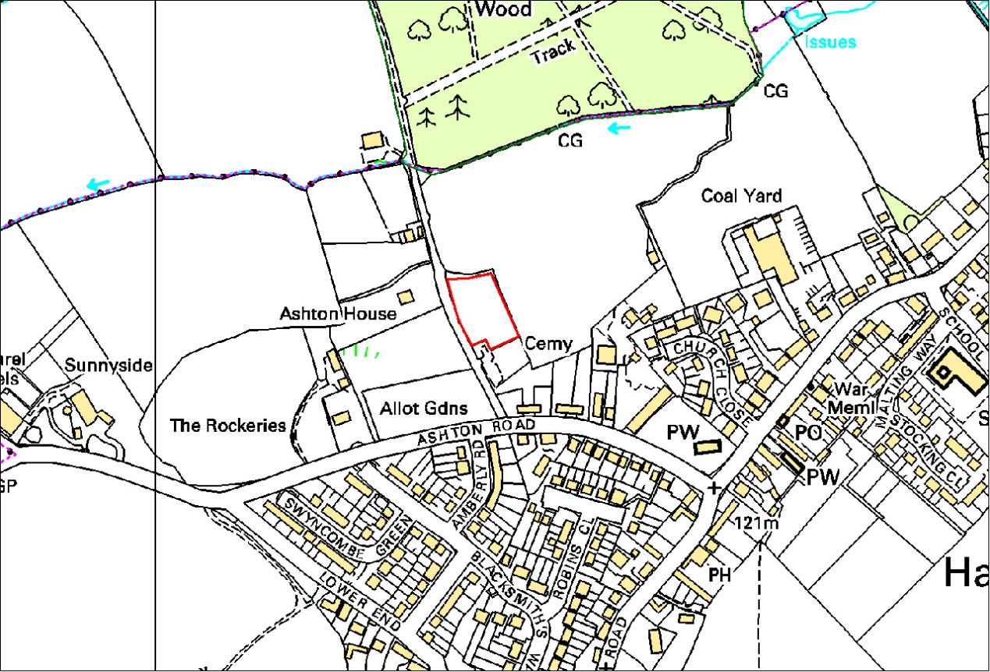

The Pocket Park site is outlined in red.

# Survey background

Northamptonshire County Council requested an outline survey of the potential Hartwell Pocket Park site, to be undertaken by The Wildlife Trust for Northamptonshire, in order to indicate the features of interest and to suggest possible management prescriptions that would deliver benefits for the wildlife of the site.

Pocket Parks are a county-wide initiative established in the 1980s. They are open spaces owned and managed by local people, but with assistance and support from Northamptonshire County Council.

The survey was carried out on the 12th July 2007 by Bruce Shortland BSc (hons), MIEEM, County Wildlife surveyor for The Wildlife Trust BCNP (Bedfordshire, Cambridgeshire, Northamptonshire and Peterborough).

This report assesses the ecological interest of the site, the features and species within the site and its immediate surroundings

# Habitat survey methodology

Ecological surveys were carried out, to ascertain the general ecological value of the land contained within the boundaries of the site and to identify the main habitats and associated plant species, with notes on the fauna utilising the site also included.

An ecological Baseline of the species and habitats present was determined by an extended Phase 1 Habitat Survey (JNCC 1993 as amended by IEA (IEMA) 1995). A Phase 1 Habitat Survey identifies and classifies habitats on the site, whilst the extension to a Phase 1 approach involves a more detailed survey of these habitats, as outlined in the following list:

* Identification of species present (predominantly a botanical survey but also taking note of other species observed).
* An assessment of the overall wildlife value of the site.
* An assessment of the potential of the site to support other species, particularly species protected under wildlife legislation such as the Wildlife and Countryside Act 1981, the Conservation (Natural Habitats & C.) Regulations 1994 and the Protection of Badgers Act 1992.

Using the above method, the site was classified into areas of similar botanical community types with a representative sample of those species present at the time of the survey being described.

# Faunal surveys

Obvious faunal activity, such as birds, insects or mammals observed visually or by call during the course of the surveys, was recorded. Specific attention was paid to any potential use of the site by protected species, Biodiversity Action Plan (BAP) species, or other notable species.

# Site description

The site consists of a small field of approximately 0.3 hectares to the north of the village cemetery in the village of Hartwell (SP784505)

An overly managed hedgerow runs along the periphery of the cemetery boundary (To the south). The Western boundary holds a relatively species-rich hedgerow with good structure that runs along the track. The northern boundary is stock netted with a defunct hedgerow with several ash trees scattered along its length and elm suckers. The eastern boundary is dominated by 10 poplars, with occasional Cyprus trees.

The site has a slight slope towards the northern end of the field.

# Ecological features

The following habitats/features were identified as being present on the proposed Pocket Park site:

* Hedgerow
* Grassland – Neutral and MG1

A small number of common grassland butterflies were recorded as well as rabbit *Oryctolagus cuniculus* and common shrew *Sorex araneus*.

A full list of all of the species seen during the site visit are listed at the end of this report.

# Habitat evaluation

## Hedgerows

The northern and western hedges are relatively species rich. The western hedge also has a woodland associated flora, with species including dog’s-mercury *Mercurialis perennis*, herb-robert *Geranium robertianum* and garlic mustard *Alliaria petiolata.*

## Grassland

The majority of the grassland has a sward height of approximately 50 cm with grass species creating a relatively dense sward. Generally the grassland is not particularly species-rich, although in some places a reasonable number of wild flowers occur such as common knapweed *Centaurea nigra*, wild carrot *Daucus carota* and meadow vetchling *Lathyrus pratensis*. There is an area of rough MG1 grassland towards the southern end of the western boundary consisting of false-oat grass *Arrhenatherum elatius*, stinging nettle *Urtica dioica* and creeping thistle *Cirsium arvense.* In places a more neutral grassland sward is present with meadow barley *Hordeum secalinum*, meadow buttercup *Ranunculus acris* and creeping buttercup *Rumex acetosa* relatively frequent accompanied by the wildflowers mentioned above.

# Opportunities for ecological development

The primary aim would be to improve the quality of the grassland by increasing the associated meadowland species, whilst reducing the coarser grasses. This should make the site more attractive to butterflies and other invertebrates as well as being more aesthetically pleasing for the local community. Cutting in late summer to maintain the level of herbs present could enhance the diversity of the grassland. *All cuttings should be removed*. An additional cut in spring, using the same method could be of benefit. This cyclic system should reduce and halt any further development of scrub and rank vegetation. The cuttings should be removed or piled in a corner of the park to help reduce the nutrients within the majority of the grassland. Ideally the MG1 area would be grazed to reduce the level of false-oat grass but in a small site such as this it is probably not feasible.

# Species list

|  |  |  |  |
| --- | --- | --- | --- |
| **Northern Hedge** |  |  |  |
| Scientific Name | Common Name | Indicator Species | DAFOR |
| *Acer campestre* | Field Maple | AnW |  |
| *Ulmus* | Ulmus |  |  |
| *Fraxinus excelsior* | Ash | w |  |
| *Prunus spinosa* | Blackthorn | w |  |
| *Crataegus monogyna* | Hawthorn | w |  |
| *Viburnum opulus* | Guelder Rose |  |  |
| *Rubus fruticosus agg.* | Rubus fruticosus agg. | w |  |
|  |  |  |  |
| **Eastern Hedge** |  |  |  |
| *Ulmus* | Ulmus |  |  |
| *Rubus fruticosus agg.* | Rubus fruticosus agg. | w |  |
|  |  |  |  |
| **Western Hedge** |  |  |  |
| *Crataegus monogyna* | Hawthorn | w |  |
| *Ulmus* | Ulmus |  |  |
| *Prunus spinosa* | Blackthorn | w |  |
| *Fraxinus excelsior* | Ash | w |  |
| *Acer pseudoplatanus* | Sycamore |  |  |
| *Rubus fruticosus agg.* | Rubus fruticosus agg. | w |  |
| *Sambucus nigra* | Elder | w |  |
| *Corylus avellana* | Hazel | AnW |  |
| *Rosa canina agg.* | Rosa canina agg. | AnW |  |
|  |  |  |  |
| *Tamus communis* | Black Bryony | w |  |
| *Urtica dioica* | Common Nettle |  |  |
| *Heracleum sphondylium* | Hogweed |  |  |
| *Dactylis glomerata* | Cock's-foot |  |  |
| *Glechoma hederacea* | Ground-ivy | w |  |
| *Hedera helix* | Ivy | w |  |
| *Stachys sylvatica* | Hedge Woundwort | w |  |
| *Galium aparine* | Cleavers |  |  |
| *Mercurialis perennis* | Dog's Mercury | AnW |  |
| *Epilobium hirsutum* | Great Willowherb |  |  |
| *Geranium robertianum* | Herb-Robert | w |  |
| *Alliaria petiolata* | Garlic Mustard | w |  |
| *Geum urbanum* | Wood Avens | w |  |
| *Ranunculus repens* | Creeping Buttercup |  |  |
| *Arrhenatherum elatius* | False Oat-grass |  |  |
| *Hieracium* | Hieracium |  |  |
|  |  |  |  |
| **Grassland** |  |  |  |
| *Arctium minus* | Lesser Burdock | w |  |
| *Cynosurus cristatus* | Crested Dog's-tail |  | R |
| *Dactylis glomerata* | Cock's-foot |  | O - F |
| *Deschampsia cespitosa cespitosa* | Tufted Hair-grass | w | LF |
| *Festuca* | Festuca spp. |  | A |
| *Holcus lanatus* | Yorkshire-fog |  | D |
| *Hordeum secalinum* | meadow barley | n | O |
| *Anthriscus sylvestris* | Cow Parsley |  |  |
| *Centaurea nigra* | Common Knapweed | n | LO |
| *Cerastium fontanum* | Common Mouse-ear |  | O |
| *Cirsium arvense* | Creeping Thistle |  | O - LA |
| *Cirsium vulgare* | Spear Thistle |  | O |
| *Daucus carota* | Wild Carrot |  | LO |
| *Galium aparine* | Cleavers |  | O |
| *Heracleum sphondylium* | Hogweed |  |  |
| *Lathyrus pratensis* | Meadow Vetchling | n | O |
| *Plantago major* | Greater Plantain |  | R |
| *Potentilla reptans* | Creeping Cinquefoil |  | LF |
| *Pulicaria dysenterica* | Common Fleabane | n | LA |
| *Ranunculus acris* | Meadow Buttercup |  | O |
| *Ranunculus repens* | Creeping Buttercup |  | F - LA |
| *Rumex acetosa* | Common Sorrel | n | O |
| *Rumex obtusifolius* | Broad-leaved Dock |  | O - LF |
|  |  |  |  |
| **Additional species recorded** |  |  |  |
| *Vanessa atalanta* | Red Admiral |  |  |
| *Maniola jurtina* | Meadow Brown |  |  |
| *Thymelicus sylvestris* | Small Skipper |  |  |
| *Chorthippus parallelus* | Meadow Grasshopper |  |  |
| *Oryctolagus cuniculus* | Rabbit |  |  |
| *Sorex araneus* | Common Shrew |  |  |
|  |  |  |  |
| AnW | Ancient woodland indicator | |  |
| W | woodland indicator |  |  |
| N | neutral grassland indcator | |  |

**Appendix 2**

**Hartwell Pocket Park – Ashwood Acre**

**Constitution**

|  |  |
| --- | --- |
| **NAME:** | Hartwell Pocket Park Management Group |
| **LOCATION:** | Rowley Wood Lane, Hartwell, Northants – field adjacent to and north of the cemetery – Grid Ref: SP783505 – now known as *Hartwell Pocket Park – Ashwood Acre* |
| **OBJECTIVES:** | Main objectives – see Management Plan |
| **POWERS:** | 1. In furtherance of the objectives, but not otherwise, the Management Group may exercise powers to: 2. manage the site named above on behalf of the Parish Council to achieve the objectives and maintain and equip it for use. 3. employ such staff (who shall not be members of the management group) as are necessary for the pursuit of the objectives under current employment legislation. 4. take on rights of use and management of the site as per the agreed Management Plan. 5. ensure that appropriate insurance for the site and activities on it is provided by the Parish Council 6. follow the Management Plan to ensure that the organisation keeps to any agreements made with the Parish Council. 7. encourage local volunteers to help with carrying out conservation and amenity tasks as specified in the Management Plan. 8. where necessary employ and supervise qualified contractors, with the approval of the Parish Council, to do specialised tasks where required. 9. report to South Northamptonshire Council, Northamptonshire County Council, Hartwell Parish Council or other agency or organisation damage, danger or issue that are within their area of responsibility. 10. keep the Parish Council, local residents, the Parish Church, Community groups and school informed and involved in activities, fundraising and progress. 11. keep the County Pocket Parks Officer informed and complete and return the Pocket Park annual diary. 12. organise fundraising activities. 13. seek and consider specialist advice from authorities and expert organisations when appropriate. 14. adhere to the laws applicable to the site and its management such as the Wildlife and Countryside Act, Crime prevention Act, Disability Discrimination Act and the Health and Safety at Work Act. 15. review the action plan section of Management Plan every 5 years. 16. ensure visitors and volunteers have safe enjoyment of the park. 17. manage contractors effectively to ensure safe working practices. 18. ensure that activities in and use of the park are consistent with the expectations of visitors to the cemetery to have a degree of tranquillity. 19. amend the Management Plan at a special meeting with appropriate required votes, following approval by the Parish Council at an open meeting where the pocket park group make necessary presentation. 20. The Management Group will encourage the local community groups to support, visit and enjoy the pocket park in accordance with the management plan for example, the Primary School, Playgroup, Parent and Toddler Group, Parish Church, Tuesday Circle, Women’s Institute, Brownies, Beavers and Guides. |
| **MANAGEMENT GROUP:** | 1. The Management Group shall number up to 10 persons including three honorary officers, (Chairperson, Secretary and Treasurer) elected at the Annual General Meeting. 2. At least one member of the Management Group shall be a member of the Parish Council, acting as a point of liaison between the two organisations. Either the Parish Clerk or another Parish Council member shall act as Treasurer. 3. The group shall meet not less than twice a year. Membership of the group shall be decided at the annual general meeting. 4. All members of the Management Group shall retire from office at the conclusion of the AGM following the date on which they came into office, but they may be re-elected or re-appointed. 5. If casual vacancies occur among the elected members of the Management Group, it shall have power to fill these from among the Friends of the Pocket Park. 6. Only members over the age of eighteen are eligible to serve as honorary officers (Chair, Treasurer, and Secretary). 7. Each Management Group member on election will receive a copy of the constitution. |
| **MEMBERSHIP:** | 1. The Management Group shall invite local residents who support the aims and objectives of the park as stated in the management plan to become Friends of Hartwell Pocket Park with the secretary maintaining a list of such members. Friends of Hartwell Pocket Park will be known as full members with power to vote at the Annual General Meeting and special general meetings. Only Friends of Hartwell Pocket Park will be eligible to join the Management Group. 2. The Management Group may, by resolution passed at a meeting thereof, terminate or suspend the membership of any Friend of Hartwell Pocket Park, if in its opinion, his/her conduct is prejudicial to the interests and objectives of the Pocket Park, provided that the individual member has the right to be heard by the Management Group before the final decision is made. |
| **ANNUAL GENERAL MEETING:** | 1. The Annual General Meeting (AGM) of the pocket park shall be held in June at a date to be agreed. Public notice must be given 14 days beforehand. 2. The AGM will receive reports on activities concerning the park and a financial report. 3. The AGM will elect honorary officers of the Management Group (Chair, Treasurer, and Secretary) from among the Friends of Hartwell Pocket Park. This shall be by show of hands. In the event of a tie, the Chairperson or appointed deputy shall decide. 4. The AGM will elect other members of the Management Group. 5. The Parish Council shall confirm, through its representative, the appointment of a qualified auditor for the coming year to audit the accounts of the park and ensure that the audit is completed. 6. The AGM will consider and vote on any proposals to alter this constitution in accordance with the ‘Amendment’ clause below. 7. The AGM will consider any other business of which due notice has to been given. |
| **ASSETS/PROPERTY/EFFECTS:** | 1. It is the responsibility of the Management Group at all times to ensure that assets, property and effects of the pocket park are maintained in good order. 2. Risk assessments will be carried out (in line with current Health and Safety recommendations) and reviewed regularly to protect users, volunteers and contractors. 3. The Parish Council may give twelve months’ notice to the Management Group requiring the reinstatement of part or all of the land designated for the park as burial land at the expense of such pocket park funds as are available. |
| **AMENDMENT:** | 1. Any amendment to the Constitution will normally be made at an AGM by a simple majority of Management Group members present or through a special meeting called for the purpose with 14 days’ notice. 2. For the purpose of amendment to the Constitution made at the AGM or at a special meeting a quorum of five group members shall be required. |
| **INCOME/EXPENDITURE:** | 1. It is the responsibility of the Treasurer and Group to keep proper accounts, tabled at each group meeting. 2. A summary statement of audited accounts shall be presented at the AGM. 3. The accounting year shall run from April to March. 4. Funds for the Pocket Park will be held in a ring fenced subsidiary account of the Parish Council. Any cash spending over £50 will be subject to the approval of the Management Group. 5. Management Group members should have no vested interest in such financial decisions. If a conflict should arise, group members must declare an interest and not participate in the decision. |
| **DISSOLUTION:** | 1. The Pocket Park may be dissolved, if deemed necessary, by a clear majority decision of the Management Group members after explanation/discussion. The Management Group’s decision must be endorsed by vote at a subsequent AGM or a Special General Meeting properly convened. 2. NCC’s Pocket Parks Officer should be given 30 days’ notice of such a meeting. 3. Any funds and other assets remaining shall be donated to the Parish Council to be used at the Council’s discretion, for example to return the site to its original state, support other pocket parks (via the NCC Pocket Parks Officer) or to support local charities. 4. The information folder about the group is to be returned to Pocket Parks Officer so that if other residents/volunteers appear interested in the future of the park, another group can be formed with the support of this background information. |

**This Constitution was adopted as the constitution of the Hartwell Pocket Park Management Group at a public meeting of the interim management group held on 19th March 2008.**

**Appendix 3**

**Police liaison report**

**Notes from meeting with Northants Police**

11th October 2007 – 9.30am

Hartwell Potential Pocket Park

Ruth Douglas, Pocket Parks Officer, Northamptonshire County Council

Mike Scragg, Crime Prevention Design Advisor, Northants Police

**Background**

Ruth Douglas invited Mike to see the proposed site and give advice on how the group can prevent crime through good design. The group who are working towards establishing a pocket park are researching information from various sources such as Wildlife Trust, Site and Monuments Records etc. This information will feed into their Management Plan and help them to make informed decisions about the location and type of features.

The site is down Ashwood Lane north of the new cemetery. It has been an unmanaged paddock for about 2 years. Currently there is very little antisocial behaviour in this area. There is natural surveillance from a bridleway well used by walkers and from 2 villager caretakers who maintain the cemetery as well as villagers who maintain loved ones graves. Although this site is unlikely to attract major problems, consideration must be given as the location of the park being adjacent to the cemetery means that any resulting anti-social behaviour could have direct impact on the cemetery user, mostly those who are grieving loved ones.

**Recommendations**

These are the recommendations resulting from the meeting:

*Design -*

* Install robust, solid features and furniture
* Keep one entrance/ exit point
* Keep it fairly open with a sight line through to back of park. Don’t fill space with trees and shrubs. Large thicket areas provide places for ‘hiding out’ (this doesn’t mean don’t plant any trees it just means find a balance and most of all consider how large trees will be in 5 years time and how safe the site will feel for visitors as we don’t want them to be put off from walking around).
* Keep picnic benches and main more formal features on the south side of the park so they can be overlooked by walkers using the bridleway and cemetery.

*Management -*

* Keep and maintained cemetery hedge as it is now – well clipped.
* Keep robust a management system – by: reporting an incident when it is occurring to the police on main Northampton number; reporting an incident after it has happened to a member of Northants Police Community Safety Team member; and use Parish Council methods of communication i.e. notice board, meetings, newsletter, letters to Parishioners, to inform residents of an incident.
* Response promptly to incidents of littering, vandalism and graffiti by cleaning or repairing features.

**Appendix 4**

Risk Assessment Forms

**Site Risk Assessment – Sept 2016**

Risk Assessment Form

|  |  |
| --- | --- |
| Name of Pocket Park: Hartwell Pocket Park – Ashwood Acre | Date form completed: 16/09/16 |
| Completed by: (Name) Eloise Smith / Simon Smith / Derek Hawley | Next Review Date: Sept 2017 |

|  |  |  |  |  |  |  |
| --- | --- | --- | --- | --- | --- | --- |
| **Hazard** | **People at Risk** | **Risks** | **Existing Controls** | **Risk Level** | **Precautions** | **Notes** |
| Furniture e.g. seats, picnic table | Anyone | Splinters | New / good condition and only presents a hazard if faulty or damaged – therefore requires some level on monitoring such as every other month. | Low | Monitor condition of equipment. | All new equipment, inspected and in good condition. |
| Rabbit scrapings and/or holes  Exposed roots | Visually impaired, children | Twisting ankle | Paths to be checked regularly and holes filled. | Low – (slight & sometimes) | Monitor to check problem to does not increase and affects other areas of the park | Un-even signs to be posted during main events. |
| Trees | Anyone | Fatality | Monitor trees over hanging public areas regularly – monthly noting that some species are more likely to drop branches than others.  External expertise is sought when required | Low | Attend training course or seek advice | Deadwood on trees is a threatened habitat worth conserving and doesn’t automatically mean branches will fall. |
| Shrubs especially new ones  Nettles, stinging plants, tics  Wasp stings | All especially children  All especially children | Tripping  Stings rashes  Tic adhesion | Marked with stick and or cover  Mark wasp nests & clearly and cordon off. | Low  Low | Visual inspection. Remove near gates notice board paths seats etc  First aid box |  |
| Dog and fox faeces | All | Toxicara |  | Low | Visual inspection. Remove with gloves to special dog bin at entrance to park.  Wash hands/ use hand gel |  |
| Sharps/ fly tipping | All especially children | Cuts skin punctures  HIV |  | Low | Visual inspection  Remove to sharps bin |  |
| Moving cars in lane | All | Injury or death | Close main gate | low |  | Low traffic volume in lane |
| Contact with micro – organisms inc. tetanus, leptospirosis | All | Infection |  | low | Advise tetanus inoculation for working party volunteers  Good hygiene |  |
| Lifting heavy items e.g. bark sacks, machinery | Volunteers | Muscle strain |  | Medium | Reminder of good manual handling practice prior to events |  |
| Use of tools  Rakes | Volunteers | Cuts /bruises | Safety briefing before start of working party.  Check for any damage before use. Keep clear of others. | Low | Keep close supervision during use, especially when young people are using them. | Parents are to supervise their own children. |
| Use of power tools  Mower/ strimmer | Volunteers | Cuts /bruises  from flying stones | Safety briefing before start of working party.  Check equipment for any damage before use. Keep well clear of others, particularly children. | Low | Only to be used by adults who are experienced in the use of this equipment. PPE to be worn (Strimmer – hat, visor ear defenders). | Equipment is regularly serviced. |
| Hot liquids  (Tea / Coffee) | Anyone | Burns | Flasks served by committee members | Low | Supervise serving of hot drinks (by adults only) | N/a |

***Hay Raking Risk Assessment***

***Hartwell Pocket Park – Each September***

Risk Assessment Form

|  |  |
| --- | --- |
| Name of Pocket Park: Hartwell Pocket Park – Ashwood Acre | Date form completed: 14/01/17 |
| Completed by: (Name) Simon Smith / Derek Hawley | Next Review Date: Jan 2018 |

|  |  |  |  |  |  |
| --- | --- | --- | --- | --- | --- |
| **Hazard** | **People at Risk** | **Risks** | **Control of risks** | **Risk Level** | **Notes** |
| Use of Large hay rakes | Anyone raking or around area. | Contact of rake with, eyes limbs.  Splinters | * Inspection of tools * Demonstration of safe use at start. * Safety talk prior to work starting alerting volunteers to safe use/ be aware. * Someone to keep an eye on hay rake usage | Low |  |
| Airborne particles | Anyone in area down wind. | Dust in eyes | * Wear impact resistant goggles, BS EN 166. Work with back to wind. * Inspection of tools * Safety talk prior to work. | Low |  |
| Contact with micro-organisms inc. Tetanus, Leptospirosis | Anyone in park | Leptospirosis, Hepatitis A | * Advise participants to have Tetanus inoculation. * Advise of symptoms of Leptospirosis, Hepatitis A and others. * Follow good hygiene practice, ensuring hands are washed before eating, drinking or smoking | Low |  |
| Bee, wasp stings | Anyone in park | Stings, allergic reactions | * Committee to carefully check park for nests (in trees or underground). If found, nest to be marked and cordoned off with plastic fencing. * Pre-start briefing; warning of presence of bees/wasps. 1st aid kit on site if required. | Low |  |
| Slips, trips and falls | Anyone in park | Sprains, broken limbs | * Check for rabbit holes before event. * Plan in advance any lifting of heavy or awkward items. * Clear route any stone or materials are to be carried over. * Train all in safe lifting, carrying and moving techniques. * Designate people to load and unload tools. * Provide carrying aids, e.g. wheelbarrow. * Heavy items will be carried between two people. * Limit number of tools an individual carries. * Cover any dug holes or cross ditches to prevent falls. * Leave site clear of material and debris at all times when it is unattended. | Low |  |
| Slips, trips and falls | Anyone in park | Sprains, broken limbs, damage to eyes | * Clearly mark newly planted fruit bushes/ trees to prevent trips. | Low |  |
| Unsafe overhanging branches | Anyone in park | Minor cuts, damage to eyes | * Monitor to check site prior to event, remove any dangerous branches etc. | Low |  |
| Use of wooden handled tools | Those using wooden handled tools | Splinters | * Ensure all tools are inspected prior to use, rake handles are secure and splinter free. * Gloves should be worn (not for sledge hammers) |  |  |
| Hot liquids (coffee, tea) | Anyone serving, drinking hot liquids | Burns | * Ensure adult committee members serve hot drinks from flasks. | Low |  |

**Hartwell Pocket Park**

**Five year work plan 2013 - 2017**

|  |  |  |  |  |  |  |
| --- | --- | --- | --- | --- | --- | --- |
|  | **MANAGEMENT OPERATIONS** | **2013** | **2014** | **2015** | **2016** | **2017** |
| **Access and security** | Maintain access paths in good order repairing where necessary | Check and maintain as necessary | Check and maintain as necessary | Check and maintain as necessary | Check and maintain as necessary | Check and maintain as necessary |
|  | Keep open sight lines from lane and gate | Check and maintain as necessary | Check and maintain as necessary | Check and maintain as necessary | Check and maintain as necessary | Check and maintain as necessary |
|  | Maintain high expectations in use of park keeping in good order, quickly repairing any damage | Weekly checks - maintain as necessary | Weekly checks - maintain as necessary | Weekly checks - maintain as necessary | Weekly checks - maintain as necessary | Weekly checks - maintain as necessary |
|  |  |  |  |  |  |  |
| **Habitat creation** | Maintain bird and bat boxes in good order | Check and maintain as necessary | Check and maintain as necessary | Check and maintain as necessary | Check and maintain as necessary | Check and maintain as necessary |
|  | Demonstration hedge – maintain to avoid encroachment on to path | Maintain as necessary | Maintain as necessary | Maintain as necessary | Hedge to be laid | Maintain as necessary including newly laid hedge |

|  |  |  |  |  |  |  |
| --- | --- | --- | --- | --- | --- | --- |
|  | Lay hedge once component plants are of sufficient size | Take advice on when to lay hedge | [Consider hedge laying 2015] | Consider hedge laying 2016 | Hedge to be laid | Annual maintenance |
|  | Clear out bottoms of coppice trees and mulch to encourage growth | Annually until first cut | Annually until first cut |  |  |  |
|  | Cut coppice areas when sufficiently mature |  | Possible year for first cut – autumn/winter |  | Some trial coppicing | Coppicing of trees across from newly laid hedge + trial coppicing behind hedge |
|  |  |  |  |  |  |  |
|  | Install log piles to develop habitats | Install first log pile | Consider installation of new log piles | Consider installation of new log piles | Consider installation of new log piles | Consider installation of new log piles |
|  | Develop plant range in bee/butterfly bank | Ongoing | Ongoing | Ongoing | Ongoing | Add additional plants for autumn flowering |
|  | Keep log edges to bank in good order | Extend and maintain log edges with locally sourced materials | Ongoing maintenance | Ongoing maintenance | Ongoing maintenance | Ongoing maintenance – use materials from coppicing to improve bank edges |
|  | Bulb planting | Autumn – plant spring bulbs | Autumn – plant spring bulbs | Autumn – plant spring bulbs | Autumn – plant spring bulbs | Autumn – plant spring bulbs |
|  |  |  |  |  |  |  |

|  |  |  |  |  |  |  |
| --- | --- | --- | --- | --- | --- | --- |
| **Habitat management** | Mow grass alongside main path – remove arisings – composting | Spring and summer | Spring and summer | Spring and summer | Spring and summer | Spring and summer |
|  | Mow meadow area | March/April and September | March/April and September | March/April and September | March/April and September | March/April and September |
|  | Mow grass paths | Throughout growing season | Throughout growing season | Throughout growing season | Throughout growing season | Throughout growing  Season |
|  | Clear around newly planted trees and mulch | Throughout year as necessary | Throughout year as necessary | Throughout year as necessary | Throughout year as necessary | Throughout year as necessary |
|  | Maintain and prune heritage fruit trees – annual mulch | Maintain as necessary | Maintain as necessary | Maintain as necessary | Maintain as necessary | Maintain as necessary |
|  | Cut back perimeter hedge – staged improvements | Autumn/ winter | Autumn/ winter | Autumn/winter | Autumn/winter | Autumn/winter  Maintain hedge to avoid encroachment across perimeter path |
|  | Maintenance of bee/butterfly bank | Ongoing through year | Ongoing through year | Ongoing through year | Ongoing through year | Ongoing through year |
|  | Wild flower survey | Summer |  | Summer |  | Consider new survey for summer 2017 |
|  |  |  |  |  |  |  |
| **Facility**  **installation and management** | Maintain benches for safety and appearance | Summer | Summer | Summer | Summer | Summer |
|  | Mowing edges of main path | Ongoing throughout season as necessary | Ongoing throughout season as necessary | Ongoing throughout season as necessary | Ongoing throughout season as necessary | Ongoing throughout season as necessary |
|  | Annual inspection of equipment and remedial action | Summer | Summer | Summer | Summer | Summer |
|  | Health and safety audit and follow up action | Spring | Spring | Spring | Spring | Spring |
|  |  |  |  |  |  |  |
| **Communication** | Maintain and update signs at park gate | Spring/summer | Spring/  Summer | Spring/  Summer | Spring/  summer | Spring/  Summer |
|  | Revise interpretation board content and commission new boards | Review of relevance of text on boards | Review of relevance of text on boards | Rewrite text in light of developments to date | Review of relevance of text on boards | Install new information boards |
|  | Keep main notice board in good order with clear permanent information | Ongoing | Ongoing | Ongoing | Ongoing | Ongoing |
|  | Annual report and AGM – public meeting | June | June | June | June | June |
|  | Agendas and meeting notes on park website and village website | Ongoing | Ongoing | Ongoing | Ongoing | Ongoing |
|  |  |  |  |  |  |  |
| **Promotion and publicity** | Recruit new volunteers and Friends of the Park | New recruitment drive - spring and summer | Ongoing | Ongoing | Ongoing | Ongoing |
|  | Updates on events and activities in *Hartbeat –* twice yearly | Spring/  Autumn | Spring/  Autumn | Spring/  Autumn | Spring and autumn | Spring/  Autumn |
|  | Promote volunteer working parties on village website and notice boards | Ongoing | Ongoing | Ongoing | Ongoing + events on Facebook | Ongoing + events on Facebook |
|  | Keep park website up to date – pictures/agendas and meeting notes/coming events | Ongoing | Ongoing | Site redesigned | Ongoing | Ongoing |
|  | Annual public event | Summer | Summer | Summer | Summer | Summer |
|  | Encourage use by local children and young people’s groups for education and enjoyment | Ongoing | Ongoing | Ongoing | Ongoing | Ongoing |

**Appendix 6**

**Ashwood Acre - Hartwell Pocket Park**

**Management Plan Summary Evaluation of Progress, January 2011 with revisions January 2013, December 2014**

**and January 2017**

|  |  |
| --- | --- |
| **AIM 1 To create the as an area for quiet enjoyment, recreation and education for the benefit of the community of all ages** |  |
| **OBJECTIVES** |  |
| 1a. The park should be capable of a variety of quiet uses by individuals, small groups, village groups and include a small space where people could gather for quiet events. | * Achieved – regularly visited by individuals of all ages, visitors to the cemetery, children’s groups. A specific place for small gatherings is the log ring. |
| 1b. The park will be attractive to young children with paths, places to explore and things to observe enabling them to enjoy and respect the countryside. | * Achieved – clear enjoyment by groups and individual children; grass paths to wigwam; log ring draws children in as does perimeter path with various exits. Willow arch extended 2011. Good levels of use by children’s groups in 2014 (primary school/pre-school/beavers/cubs and brownies, child minder groups) ***2017*** ***Park remains very popular with young children and leaders of children’s groups.*** |
| 1c. The park will enable demonstrations of country crafts and skills such as hedge laying and species identification. | * Partially achieved - species identification takes place within existing events e.g. children’s mini beast hunts, plant identification expert involved . The demonstration hedge is growing well but is not yet ready for laying. ***2017 Hedge now laid by group members with aid of trainers from The Conservation Volunteers.*** |
| 1d. The park will feature interesting artefacts e.g. sculptures, willow structures, log seating in keeping with its natural surroundings. | * Substantially achieved – willow structures and log ring seating installed. Possibility that willow nursery could provide materials for willow weaving. |
| 1e. The park will have seating to allow people to relax and enjoy the park. | * Achieved – 4 benches including picnic bench – two locally made by volunteers, one donated by WI. |
| 1f. Interpretation and notice boards will inform visitors about interesting features, wildlife news and group activities and events. | * Achieved – notice boards at gate provides plan of park, guidelines, forthcoming events, record of species identification, interpretation/information boards for main features of the park mounted on large logs (from local Salcey Forest) set into ground. Contract exists to update information boards as park develops. ***2017 Information boards updated on new support oak logs.*** |
| 1g. The group will monitor park features such as seating, information boards and maintain when necessary | * Achieved – group members regularly monitor the park and deal with any damage or maintenance needs. |
| 1h. The management group will organise an annual community fundraising/social event. | * Achieved – Project launch events (2008); large scale official opening event (2009) with local groups and politicians and press present. 2010 – main event the annual hay rake. 2011 Royal Wedding. 2014 Birds of Prey. ***2017 In last two years well supported village plants sale in May together with other child friendly attractions (reptiles, owls).*** |
| 1i. A short section of the northern hedge will be cut to create a view across to Rowley Wood from Pocket Park. | * Not achieved – borrowed view has proved difficult because of scale of cutting back and ongoing maintenance required. Seems unlikely to be achieved. |
| 1j. The management group will liaise with and encourage Hartwell village school to visit pocket park. | * Largely achieved – many visits by young people’s groups in the village – pre-school, beavers, brownies etc all visit with excellent results. From 2011 the primary school has been bringing groups of pupils to the park to augment its own activities in a conservation area on the school site. School is very supportive and co-operative in enabling publicity to parents. |
| **AIM 2 To maintain and further develop the current ecological diversity of the site to encourage plant and animal life.** |  |
| 2a. The park design will include a variety of areas of interest such as woodland, wild flower meadow, an edible thicket, a marshy area and a butterfly garden while maintaining the current diversity of the hedgerows and grassland. | * Achieved – all areas of interest on the original plan have been created and are developing well with very few losses – fruiting thicket (2008); coppice (2009); demonstration hedge (2009); bee/butterfly bank garden (2008-10) – bank extended in 2012; wildflower meadow – improving (2008-16); specimen trees (2009); heritage fruit trees (2009 and 2010); range of bulbs planted (2010 - 2014). Increasing diversity of grassland and maintained diversity of existing hedges. The development of the park has encouraged more diversity of plant, bird, animal, insect and invertebrate species. Evidence from wild flower survey (2013) positive. ***2017 Further wild flower survey planned for summer.*** |
| 2b. The three grassland areas - wildflower meadow, long grass, & marshy patch will be maintained and improved through appropriate cutting, raking & removing of arisings regimes. | * Substantially achieved – wildflower meadow improving as fertility drops and persistent thistles are removed; apart from paths, grass has been allowed to grow freely throughout the summer until September mow. From 2015 there will be an early mow (March/April) of the meadow area to replicate sheep meadow grazing effect as recommended in wildflower survey. ***2017 General improvement in wild flower population though designated meadow area progressing more slowly than hoped.*** | |
| 2c. A compost area for arisings will be created and in turn a grass snake habitat. | * Achieved – arisings from annual mow and path mowing during growing season together with other green stuff are added to a large mound to encourage slow worms and grass snakes. Compost bins installed 2011. Compost used for mulching. | |
| 2d. Hedges will be maintained through trimming or laying following advice from Wildlife Trust or other expert. | * Mainly achieved – pre-existing hedges are hand maintained. Boundary hedge on Rowley Wood Lane no longer flailed. Demonstration hedge not yet ready for laying. ***2017Demonstration hedge laid late winter 2016.*** | |
| 2e. A coppice area will be planted and maintained through rotational cutting. During planting consideration will be given to the opportunity of introducing wildflowers. | * Achieved so far – coppice trees growing well with occasional cutting back of grass and mulching; trees should be ready for first cut in 2014/15. ***2017Trial cut 2016. Further larger scale cut planned for late winter 2017. Arisings to be used to augment habitat.*** | |
| 2f. The butterfly area will be regularly weeded, pruned and maintained. | * Achieved – butterfly area regularly maintained; attractive to bees and butterflies. Log bank habitats installed. Area gradually being extended along nettle bank to increase habitat diversity. Some nettles to remain.***2017 Planned to add further late flowering plants to bank.*** | |
| 2g. A fruiting thicket will be planted and maintained through mulching, pruning, weeding etc. | * Achieved – thicket first planted 2008 with additional planting 2009, 2010, 2011. Growing well with increasing amount of fruit and berries. Mulching to encourage growth. | |
| 2h. A mound will be created which can be maintained through cutting, raking and removing arisings. | * Achieved – mound became butterfly bank/garden. | |
| **AIM 3 To encourage local residents in working together to support, care for and enjoy the area.** |  | |
| 3a. Through strong initial design, the space will be inviting and accessible to all with pathways that draw visitors to key features. | * Achieved – many visitors throughout the year. The look of the park from the gate is inviting and draws people in. | |
| **3b** The site will be capable of maintenance by volunteer working groups with some locally funded professional support. | * Achieved – working parties throughout the year have successfully maintained the park to date with the addition of paid for long grass mowing in late summer only (for hay rake) by local environmental charity. | |
| 3c. Moral, practical and financial support will be encouraged from individuals and community groups through regular publicity, working groups and activities at the park. | * Achieved – park well regarded in the village (e.g. village survey 2011); good turn out for main events; core of helpers for working parties has been maintained; regular publicity through *Hartbeat* (parish council magazine); park website accessible through Parish Council website. Financial support from village produce show and summer events. | |
| 3d. There will be good and regular communication with the church, parish council, Pocket Parks Officer etc. | * Mainly achieved – regular communication with Parish Council, invitations to key events to leaders of village groups. To 2012 contact as necessary with Northants Pockets Park Officer following excellent support in establishing the park. Park was used as an exemplar park in annual Pocket Parks Summer Sortie 2011. Regrettably Pocket Park Officer role no longer exists. | |
| 3e. The Pocket Park Management Group will meet regularly to monitor and plan actions required to complete the works as described in the Management Plan. | * Achieved – cohesive group that maintains as well as manages the park. Regular meetings as required to organise maintenance, events and further development. | |
| 3f. Write & review when necessary risk assessments. | * Achieved – overall risk assessment completed and reviewed. Specific risk assessments for special events. ***2017 Most recent update January 2107.*** | |

**Additional note: The park gained Green Flag Community Award status in 2011, 2013, 2015 and will be entered again in 2017.**